- About us For your reference https://www.charitywater.org/about, https://www.brac.net/about-us/ , https://www.care.org/about-us/

Women’s Health Initiative (WHI) is a Community-based organization dedicated to empowering vulnerable young people to make smart choices and decisions for sustainable development. Women Health Initiative (WHI) was founded in BO City in Sierra Leone in 2010 and registered by BO council in 2018. Our organization was founded to respond to social and health community issues. We use different innovative approaches, including sports and entertainments to address public health and social issues in community in Sierra Leone. Women Health Initiative has experienced and skilled staff and volunteers who have expertise to addressing public health issues in the community. Currently, Women Health Initiative (WHI) has 15 staff and 25 volunteers. Women Health Initiative (WHI) has implemented several public health projects and has achieved consistent changes for vulnerable people in BO district, in the Southern Province of Sierra Leone.
Our vision and Mission:

Women’s Health Initiative strives for equal and equitable rights and opportunities for vulnerable people in Sierra Leone by addressing social determinants of health. We need Sierra Leone free of inequalities, inequities, injustices, and social discrimination.
Mission: Women Health Initiative is dedicated to empower vulnerable people in Sierra Leone to make smart choices and decisions in their lives for sustainable development.
Women Health Initiative (WHI) is dedicated to improve knowledge, confidence and services for vulnerable people in Sierra Leone in order to make the best choices for their lives.
Our Values: Accountability, Transparency, Effectiveness, Efficiency, Equity, and Equality.

Our work ……….

Our Leadership
Meet the leaders and board members who guide the Women’s Health Initiative’s work for a better future.

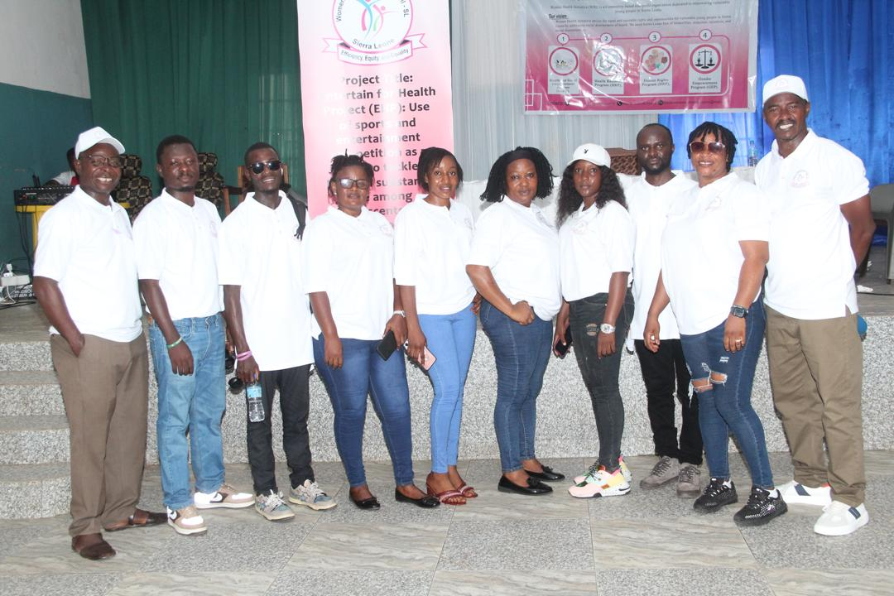
Impact ----- urareba uko ubikora too ukoze reference kubyo bakora

Kuri partners ubwo ushobora gukoresha amalogos ahobishoboka cg ukabishyira hamwe hasi too wakora search then ukayashaka biba biri online
PARTNERS:
1. BO district- Local Governance and Leaders
2. Local NGOs/Community-based organizations (CBOs)-BO district
3. Ministry of Health and Sanitation (MOHS)
4. Ministry of social welfare-BO district
5. BO city Council
6. Traditional leaders
7. Grand Challenges Canada (GCC)
Etc.
Nibindi ubona byajyamo ushingiye kuri cantent ufite

- OUR PROGRAMS: take the reference from this: https://www.rwandayvchange.org/ourprograms
HEALTH AND SOCIAL EMPOWERMENT PROGRAM (HSEP)
- Sexual reproductive Health Education Project
- Mental health awareness, screening, and services
- Public health screening, testing and treatment services at the community level
- Water, hygiene, and sanitation
- Rural and city development
- Biodiversity and conservation
- Fight against illiteracy in community
- Promotion of Sciences and technology in Sierra Leone
- Micro projects creation
- Project small business planning and education
- Promotion of youth talents for development
- Other related activities

GENDER EMPOWERMENT PROGRAM (GEP):
- Awareness of the community on Gender
- Advocacy for abilition of domestic violance and gender-based violence
- Gender and family conflict resolution
- Support of victim of Gender based violence
- Women empowerment
Economic Development for women and girls
HUMAN RIGHTS PROGRAM (HRP)
- Policies implementation and advocacy
- Gender advocacy
- Conflict resolutions and peace
- Human rights for particular vulnerable people
- Other related activities
Health Research Program (HRP):
- Surveys, evaluation
- Health studies and researches

- Our projects: for reference yoburyo wayikora wasura ino link: https://www.conservation.org/projects kndi igomba kuba dynamic kuburyo uwashaka gukora post yabikora too urebere kuri iyo ukuntu ikoze ubariko uyikora

Entertain for Health Project (EHP): Use of sports and entertainment competitions as tools to tackle harmful substance use among adolescents and youth in rural areas and the city of Bo district, Sierra Leone”. The project was funded by Grand Challenges Canada (GCC), through the Being Initiative, to test the proof of concept in Bo district and generate evidence to inform its scale-up to additional districts across Sierra Leone.

Project achievements:
The project aimed to improve mental health and reduce harmful substance use among young people in Sierra Leone through sports and entertainment competitions combined with community-based mental health promotion, screening, counselling, and psychosocial support. The project has achieved significant results as planned:
- Trained peer educators: A total of 50 young community peer educators were trained and effectively delivered project interventions across Bo district, including community-based mental health screening, counselling, and referrals.
- Improved knowledge and skills: Young people demonstrated an estimated 50% improvement in knowledge and skills related to mental health and the prevention of harmful substance use, supported by monthly sports and entertainment competitions in public spaces and playgrounds, complemented by social and behaviour change messages.
- Reduced stigma and harmful substance use: Young people demonstrated improved attitudes towards mental health, including reduced stigma and harmful substance use, through individual and group counselling, psychosocial support, and community engagement activities.
- Regular screening and referrals: Monthly mental health and substance-use screening sessions were conducted, enabling the identification of young people experiencing substance-use problems or other mental health concerns. Those requiring additional support were referred to nearby health facilities or rehabilitation centers for appropriate psychosocial support and counselling.
- Improved mental health and well-being: Overall, the project contributed to improved mental health, psychosocial well-being, awareness, and help-seeking behaviours among young people in Bo district, while creating safe and engaging platforms through sports and entertainment for delivering mental health and substance-use prevention messages.
Lessons learned:
During the past period of the project, we have learned the following main lessons:
1. The combination of mental health and substance use preventive services into public entertainment and sport competitions is the best youth-friendly and comprehensive community-based approach to reduce substance use among young people in Sierra Leone because all young people in Sierra Leone like entertainment and sport competitions, and when they come, they receive mental health and substance use preventive services. Community-based sports and entertainment attract young people, and they benefit from awareness and prevention activities, including key messages on the negative effects of substance use, screening services, counseling, and psychosocial support. The community-based entertainment and sports are effective and efficient in promoting improved mental health, reducing the use of harmful substances, and combating negative attitudes such as stigma and addiction among young people.
2. The community peer educators or community health workers (CHWs) are the best community-based approach to deliver comprehensive and stigma-free community-based mental health education and services to prevent and reduce harmful substance use among young people. Peer educators are members of their communities and have strong relationships within them. The peer educators are trusted and no stigma issues. They know better the context of their communities, and they can communicate better with them on the harmful substances and mental health conditions.
3. Community-based individual and group counseling are effective and efficient in reducing addiction to harmful substance use among young people, especially when conducted with the trained peer educators or Community Health Workers (CHWs) who have strong relationships and trust in their respective communities.
Next steps:
Mobilization of additional resources and funding from local, national, regional, continental, and international partners to sustain existing innovation activities in Bo District and support their scale-up to additional districts in Sierra Leone, starting with Bonthe, Moyamba, and Pujehun Districts in the Southern Province, during 2027- 2028.

Photos:

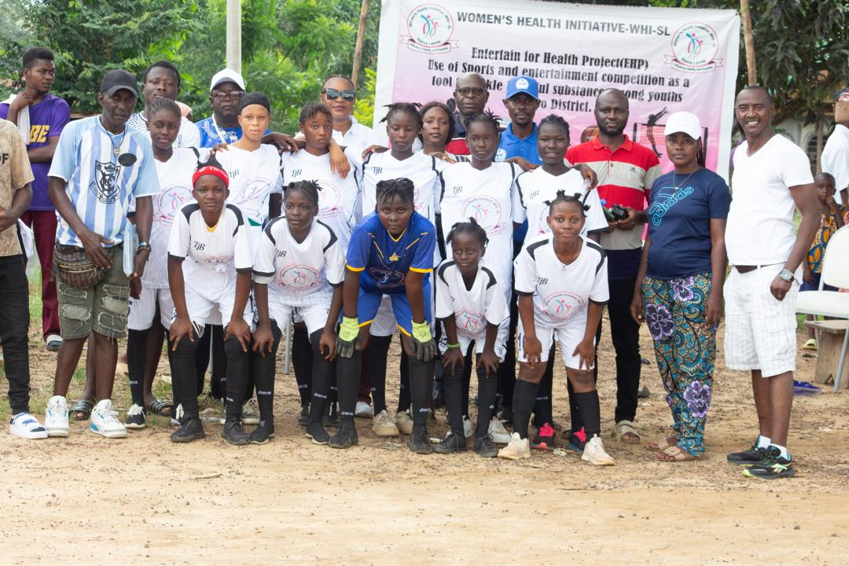

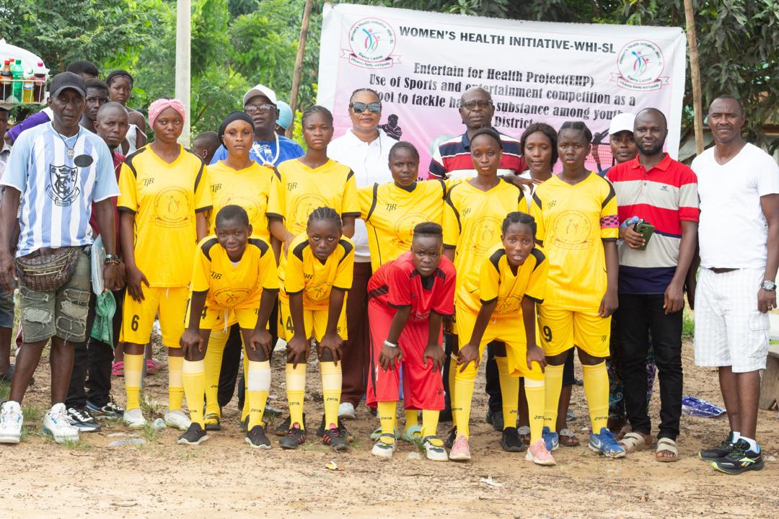

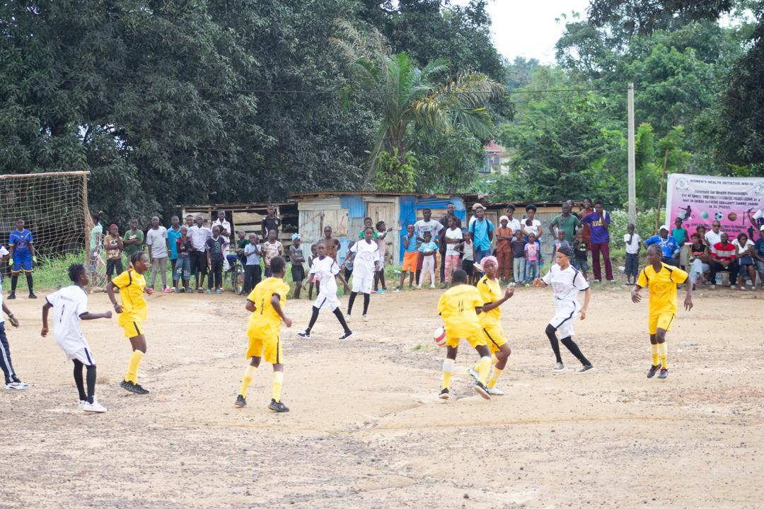

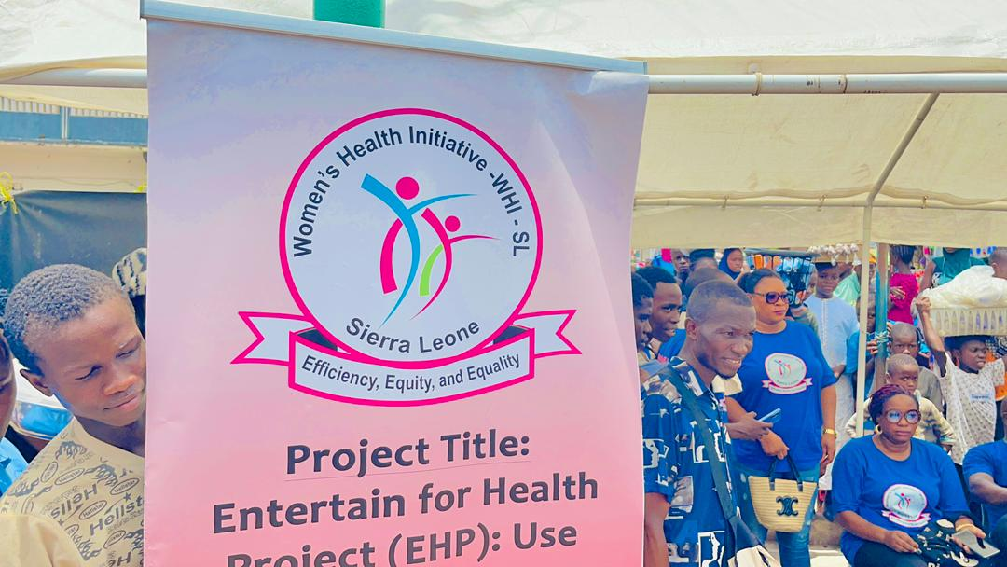

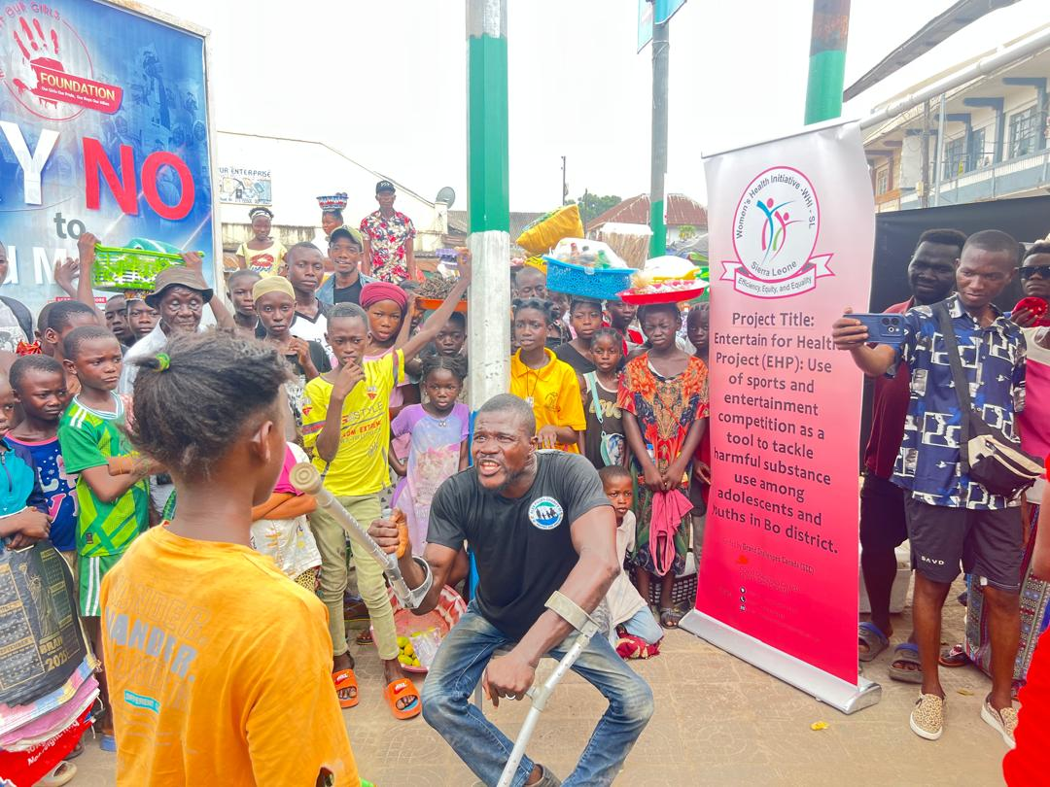

Innovation link: Entertain for Health Project (EHP) - Being | Grand Challenges Canada

Funder/Partners:
- Grand Challenges Canada (GCC)-Being Initiative


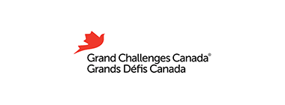

- Local stakeholders and partners: Bo district, Bo city, Ministry of social welfare - Southern Region Office, Ministry of Health and Sanitation (MOHS), Bo city council, Mental Health Unit - Bo Government Hospital, Conference of Secondary Schools Principals - Bo City, Njala University Public Health Association, Njala University Student Union, The Sierra Leone Police - Southern Regional Head Quarters, Community leaders, Chiefdoms Youth Leaders, Bike Riders, artists, Football players, Etc.
Email yiyi project ugomba gushyiraho bakwandikira: womenhealthinitiative2010@gmail.com
Work with us
Blog which must be dynamics
Nibindi website iba igomba kuba ifite nka contacts na chat yo ndumva warayisizemo too
Tuvugana yambwiyengo email ya organization nimwe bazagura azayiduha ubwo banza ukore kuri ibyo maze tumwereke

